IIBA UK BA Job Descriptions

Covers the following roles in the context of the BABOK and with reference to the SFIA skills framework
Job Name | Job Purpose | SFIA Level of Responsibility
Business Analysis Practice Lead | Plans and guides the activities of a team of business analysts and ensures the consistency and quality of their work. Acts as a centre of competence for all business analysis issues, Responsible for the overall delivery of analyst practitioners and for managing the analysis practice capability within the business. | Initiate/Influence (SFIA Level 6)  https://sfia-online.org/en/sfia-8/responsibilities/level-6
Senior Business Analyst | Builds relationships with stakeholders at all levels of the business, uncovers needs, priorities and objectives and leads the delivery of quality analysis to ensure a continuous focus on business outcomes through to delivery.  At project initiation assists in estimating costs and timescales, developing business cases and assessing feasibility.  Looks beyond specific projects to provide a wider perspective on change, managing dependencies and providing insightful views of whole programmes. | Ensure/Advise (SFIA Level 5)  https://sfia-online.org/en/sfia-8/responsibilities/level-5
Business Analyst | Builds relationships with stakeholders at all levels of the business, uncovers needs, priorities and objectives and helps to shape coherent change projects and bring about continuous focus on business outcomes through to delivery | Enable (SFIA Level 4)  https://sfia-online.org/en/sfia-8/responsibilities/level-4
Trainee /Apprentice Business Analyst | Carry out value adding Business Analysis tasks effectively under supervision/ with guidance. Acquire knowledge, skills and practical experience of the application of business analysis sufficient to become a Business Analyst capable of operating independently. | Apply (SFIA Level 3)  https://sfia-online.org/en/sfia-8/responsibilities/level-3

Role |  |  | Business Analysis Practice Lead
Job Purpose
Plans and guides the activities of a team of business analysts and ensures the consistency and quality of their work. Acts as a centre of competence for all business analysis issues, Responsible for the overall delivery of analyst practitioners and for managing and developing the analysis practice capability within the business.
Responsibilities
- Builds relationships and provides consultancy to stakeholders at all levels of the business.
- Provides a framework to facilitate a consistent approach to analysis, aligned to best practice, and is accountable for the quality of analysis delivered by members of the practice.
- Builds and provides leadership within the analysis community.
- Identifies and manages the capability of the practice, embedding improvements as appropriate.
- Assigns members of the practice to demand, based on team members current capability, areas to develop and available opportunities, identifying capability gaps where appropriate.
- Collaborates constructively with other practice leads (such as those for Engineering, those for Test) to create and operate successful approaches to the definition and delivery of change.
- Leads other analysts in task managing, coaching, and mentoring and/or line managing as required.

Minimum Requirements
Essential
- Experience of applying a broad range of techniques within the business analysis skillset to resolve business problems and clarify business requirements in a complex business environment with multiple stakeholders.
- Exposure to senior stakeholders and to strategic projects and programmes
- Advanced stakeholder management and relationship skills
- Line management experience
Preferred
- Experience of leading a Community of Practice
- Contributes to the business analysis profession

Education & Qualifications
Essential
- None
Preferred
- IIBA CBAP or BCS International Diploma in Business Analysis (or equivalent)
- Professional membership (e.g. IIBA UK, BCS, BA Manager Forum).

Select SFIA skills and SFIA levels based on the organisational need and role specialism (see table below).
Application of the BABOK Knowledge Areas/ SFIA Level of Responsibility
Business Analysis Planning & Monitoring | Elicitation & Collaboration |  |  | Requirements Lifecycle Management |  | Strategy Analysis | Requirements Analysis & Design Definition | Solution Evaluation
Level 6 – Initiate/Influence | Level 6 – Initiate/Influence |  |  | Level 6 – Initiate/Influence |  | Level 6 – Initiate/Influence | Level 6 – Initiate/Influence | Level 6 – Initiate/Influence
Application of organisational behaviours/values (example)
Communicating |  | Incisive – Leadership level |  |  | The Business Analyst Practice Lead will achieve their outcomes underpinned by these organisational behaviours & values (fictional example)
Collaborating |  | Adventurous – Leadership Level
Getting results |  | Driven – Leadership level

Role |  | Senior Business Analyst
Job Purpose
A highly experienced practitioner with a strong knowledge of a wide range of tools and techniques along with experience of deploying them in complex and ambiguous contexts.
Working across the project lifecycle, the Senior BA is highly proficient working with traditional or iterative delivery methods.
Possessing advanced interpersonal skills, the Senior BA builds strong stakeholder relationships and is seen as a trusted advisor to the business.
Responsibilities
- Liaises and builds relationships with stakeholders to understand business issues, to manage requirements in line with business needs and to facilitate definition and delivery of coherent, appropriate solutions.
- Uses business analysis techniques to provide and present a holistic evidence base and supports its use to enable informed decision making by stakeholders.
- Takes accountability for the quality of the evidence base generated to support stakeholder decision making.
- Maintains open communication channels with all stakeholders ensuring ongoing consistency of understanding regarding business needs, objectives, priorities and requirements.
- Leads other analysts in task managing, coaching and mentoring and/or line managing, as required.
- Proactively plays a leading role in building the capability and reputation of the BA Practice within the organisation and across the wider BA profession
Minimum Requirements
- Experience of applying a broad range of techniques within the business analysis skillset to resolve business problems and clarify business requirements in a complex business environment with multiple stakeholders.
- Exposure to senior stakeholders and to strategic projects and programmes
- Excellent stakeholder management and relationship skills
- Possesses a broad understanding of business and the significance of commercial constraints

Education and Qualifications
Essential
- None
Preferred
- IIBA CBAP or BCS International Diploma in Business Analysis (or equivalent)

Select SFIA skills and SFIA levels based on the organisational need and role specialism (see table below).
Application of the BABOK Knowledge Areas/ SFIA Level of Responsibility
Business Analysis Planning & Monitoring | Elicitation & Collaboration |  |  | Requirements Lifecycle Management |  | Strategy Analysis | Requirements Analysis & Design Definition | Solution Evaluation
Level 4 – Enable | Level 5 – Ensure/ Advise |  |  | Level 5 – Ensure/ Advise |  | Level 5 – Ensure/ Advise | Level 5 – Ensure/ Advise | Level 5 – Ensure/ Advise
Application of organisational behaviours/values (example)
Communicating |  |  | Incisive – Practitioner level |  | The Business Analyst Practice Lead will achieve their outcomes underpinned by these organisational behaviours & values (fictional example)
Collaborating |  |  | Adventurous – Leadership Level
Getting results |  |  | Driven – Practitioner level

Role |  | Business Analyst
Job Purpose
An experienced practitioner with knowledge of a wide range of tools and techniques, along with experience of deploying them in a range of contexts.
Proficient working with traditional or iterative delivery methods.
Possessing refined interpersonal skills, the BA works under minimal supervision.

Responsibilities
- Liaises and builds relationships with stakeholders to understand business issues, and to manage stakeholder requirements in line with business needs, to facilitate definition and delivery of coherent, appropriate solutions.
- Uses a broad range of business analysis techniques to provide and present a holistic evidence base and supports its use to enable informed decision making by stakeholders.
- Takes accountability for the quality of the evidence base generated to support stakeholder decision making.
- Maintains open communication channels with all stakeholders ensuring ongoing consistency of understanding regarding business needs, objectives, priorities, and requirements.
- Contributes to the BA Community of Practice

Minimum Requirements
- Experience of applying a range of techniques within the business analysis skillset to resolve business problems and clarify business requirements in a complex business environment with multiple stakeholders.
- Good interpersonal skills and can communicate effectively and confidently with stakeholders

Education & Qualifications
Essential
- None
Preferred
- IIBA CBAP, BCS International Diploma in Business Analysis (or equivalent), or equivalent experience

Select SFIA skills and SFIA levels based on the organisational need and role specialism (see table below).
Application of the BABOK Knowledge Areas/ SFIA Level of Responsibility
Business Analysis Planning & Monitoring | Elicitation & Collaboration |  | Requirements Lifecycle Management | Strategy Analysis | Requirements Analysis & Design Definition | Solution Evaluation
Level 4 – Enable | Level 4 – Enable |  | Level 4 – Enable | Level 3 – Apply | Level 4 – Enable | Level 3 – Apply
Application of organisational behaviours/values (example)
Communicating |  | Incisive – Practitioner level |  | The Business Analyst will achieve their outcomes underpinned by these organisational behaviours & values (fictional example)
Collaborating |  | Adventurous – Practitioner Level
Getting results |  | Driven – Practitioner level

Role |  | Trainee/ Apprentice Business Analyst
Job Purpose
An entry level role into the business analysis profession.
Carry out value adding Business Analysis tasks effectively under supervision/ with guidance. Acquire knowledge, skills, and practical experience of the application of business analysis sufficient to become a Business Analyst capable of operating independently.
This role may be supported by a Level 4 Apprenticeship in Business Analysis
Responsibilities
- With support, liaise and build relationships with stakeholders to understand business issues, and to manage stakeholder requirements in line with business needs, to facilitate definition and delivery of solutions.
- Contributes to the delivery of analyst artefacts in line with agreed quality standards.
- Uses business analysis techniques to provide and present a holistic evidence base and supports its use to enable informed decision making by stakeholders.
- Maintains open communication channels with all stakeholders ensuring ongoing consistency of understanding regarding business needs, objectives, priorities, and requirements.
- Learns and applies business analysis skills and knowledge to provide appropriate support to the business and shares learning with and beyond the analysis community.

Minimum Requirements
Essential
- Has good interpersonal skills and is able to communicate effectively with a range of stakeholders
- Possesses a general understanding of business
Preferred
- Experience of resolving business problems in a business environment

Education & Qualifications
Essential
- None
Select SFIA skills and SFIA levels based on the organisational need and role specialism (see table below).
Application of the BABOK Knowledge Areas/ SFIA Level of Responsibility
Business Analysis Planning & Monitoring | Elicitation & Collaboration |  | Requirements Lifecycle Management | Strategy Analysis | Requirements Analysis & Design Definition | Solution Evaluation
Level 2 - Assist | Level 3 – Apply |  | Level 3 – Apply | Level 2 - Assist | Level 3 – Apply | Level 2 - Assist
Application of organisational behaviours/values (example)
Communicating |  | Incisive – Entry level |  | The Trainee/Apprentice Business Analyst will achieve their outcomes underpinned by these organisational behaviours & values (fictional example)
Collaborating |  | Adventurous – Entry level
Getting results |  | Driven – Entry level

Business analysis roles and SFIA skill levels
It is understood that the role of a business analyst can differ depending on the organisational need and role specialism. This mapping is not intended to cover all possible variations or specialisms of business analysis roles.
To help adoption - these were further refined into 2 groups. SFIA skills most likely to be used and which are considered core business analyst skills. Other SFIA skills that may be used, depending on organisation/role context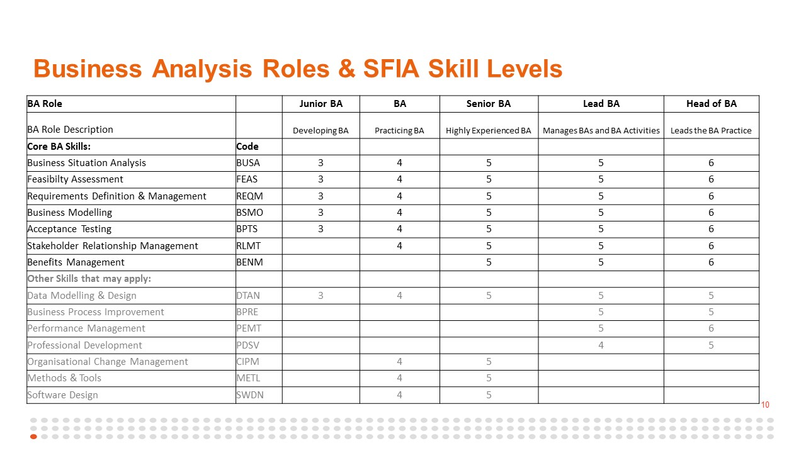

Project Complexity Dimensions

