SFIA vs iCD Mapping Research Project
Phase1: Compare the Underlying Principles and Generics

Revision date: Dec, 1 2017
Prepared by: IPA

Contents
- Skills Framework for the Information Age, SFIA - Introduction 4
  - Overall
1.1.1 Background to SFIA
1.1.2 The SFIA Foundation
1.1.3 The Success of SFIA
1.1.4 The SFIA Update Process
  - The SFIA Framework
    - Context
    - Design Principles
    - Structure
  - How SFIA Works – The SFIA Levels
  - Generic Levels of Responsibility
  - Professional Skills
    - Consistent Layout of a Skill
  - SFIA Documentations

- if Competency Dictionary(iCD) 11
  - Overall
    - Background to i Competency Dictionary (iCD)
    - Update Process
    - iCD Contents
    - iCD Implementation Status
    - iCD Supplement
  - Task Dictionary and Structure
    - Task Dictionary Overview
    - Task Dictionary Structure
    - Task Category
    - Task Major Category
    - Task Middle Category
    - Task Minor Category / Assessment Item
  - Task Profile
  - Task Assessment Level
  - Skill Dictionary and Structure
    - Skill Dictionary Overview
    - Skill Dictionary Structure
    - Skill Category
    - Skill Classification
    - Skill Item / BOK
  - Job List
  - Skill Proficiency Criteria
  - Task X Skill Correspondence Table
  - The iCD Application System
  - iCD Documentation

- SFIA & iCD Comparison of Underlining Principles 26
  - SFIA & iCD Overall Comparison
  - SFIA & iCD Detail Comparison

- SFIA & iCD Comparison of Generics 37
  - SFIA Generics vs Task Evaluation Level
  - iCD Criteria for levels of Skill Mastery

- Summary of SFIA & iCD Comparison 40

1 Skills Framework for the Information Age, SFIA - Introduction

1.1 Overall

1.1.1 Background to SFIA
The Skills Framework for the Information Age (SFIA) originated out of the collaboration of skills and competency initiatives within UK companies in the 1980s and 90s. This collaboration resulted in the SFIA Framework being published and adopted within the UK and made available through the SFIA Foundation from the year 2000. For many years the SFIA Framework has been the single global common language for describing skills and competencies required in the digital world.
Adoption of SFIA increased steadily in the early years, firstly within the UK, and subsequently, globally. SFIA has a world-wide user base of thousands of organizations and individuals in around 180 countries: there are currently (2018) some 20,000 registered users, where one user may be using SFIA across a workforce of thousands. The SFIA Framework has become the de facto global digital and IT skills framework, a global common language, and a standard for skills and competencies. SFIA is available in 6 languages; English, Spanish, German, Japanese, Chinese, and Arabic.
The SFIA Foundation found that there is more to a framework than the framework itself and, as a result, established the ecosystem necessary to support the Framework.

1.1.2 The SFIA Foundation
The SFIA Foundation (Fig 1-1) is a global not-for-profit organization that develops, maintains and makes available the SFIA Framework for use. It is funded through a modest licensing model for use of the SFIA intellectual property – with the vast majority of users able to use SFIA under a free-of-charge user license.
The SFIA Foundation is led by the SFIA Board which focuses on governance and oversees the work of the Foundation while a modest operations and business administration activity carries out the day-to-day running of the Foundation. The SFIA Council, comprising representatives from the global user base, discusses the direction of the Foundation and provides a pool of expertise. Finally, there is the global SFIA community of users, and it is this community that creates the SFIA Framework and associated products

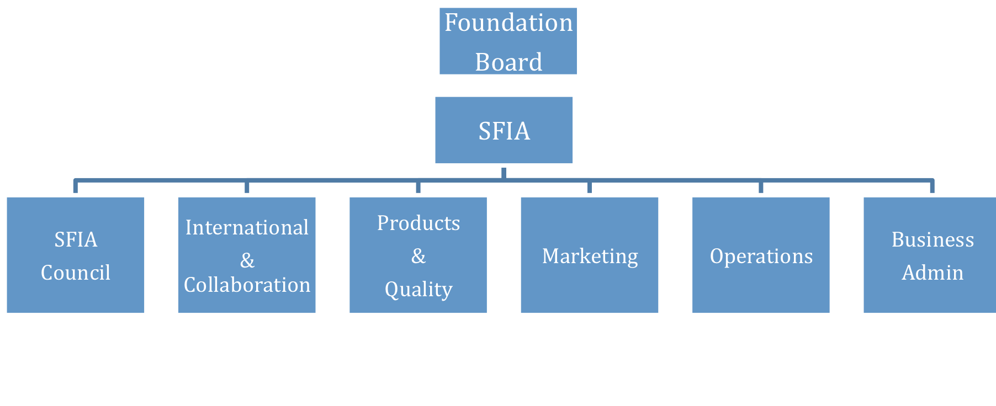

Fig 1-1 SFIA Foundation
What is unique about SFIA is the way it has focused on mobilizing the global user base to balance the needs of all stakeholders rather than to be overly driven by any one and this is a major component of the success that is SFIA – it is 'pulled' by industry and business because they want to use it rather than 'pushed' by commercial or other interests.
For more information about the SFIA Foundation, the SFIA Framework or how the framework can be used visit the SFIA Foundation website at www.sfia-online.org or contact the SFIA Foundation General Manager, Ian Seward, at ops@sfia-online.org

1.1.3 The Success of SFIA
SFIA has become a global phenomenon and the de facto global Digital and IT skills framework – it has done this without any push from the Foundation, any organization or any Government. To have achieved this without any well-resourced central drive or promotion is remarkable and is as a result of a number of key attributes.
- The Framework must be right – companies and individuals want to use it.
Users want to use SFIA because they find it to be useful in helping them to manage the skills and competencies of their staff – they are not forced to use it.
- It reflects reality and is relevant to industry and business.
It is built by industry and business for use by industry and business. It focuses on the needs of the end user rather than other interested stakeholders alone.
- It is simple, generic, extensive and independent of method or technology.
It is universally applicable.
- It requires experience of a skill to be demonstrated.
An individual has the skill at a particular level because they have performed that skill at that level in real-world situations.
- It is readily available.
It can be obtained free of charge and is available in 6 languages.
- An ecosystem has established and this is now supported for all.

While there are many other attributes that have contributed to the success that is SFIA these are perhaps the key elements and while it is impossible to identify the single most important factor, points 2 and 3 above must be out in front.

1.1.4 The SFIA Update Process
The SFIA Framework is updated by a process of open consultation involving the whole user-base. Anyone can raise a request for change and these are reviewed against the SFIA design principles and progressed accordingly by the Design Authority. At this stage new content is drafted by the volunteer user community and reviewed. Then the draft of the whole framework is assembled and reviewed again for consistency across skills and against design principles, translated and published.

1.2 The SFIA Framework

1.2.1 Context
The context for SFIA is to describe skills and address the needs of the IT and digital world, to enable a single global common language. As the commercial workplace has become increasingly global this need has become increasingly important. The Framework enables organizations to characterize their roles, identify their skill needs and to help develop the skills of their workforce. The SFIA Framework can be used by individuals to develop their own skills; by organizations to develop the skills of their workforce and enhance their organizational capability; and by Governments to secure a world-class national workforce. It can be used both internally and externally to support the purchaser-supplier interaction.
While the SFIA Framework is an important enabler and tool, it can be used in a great many different ways and underpins the capability development activities of industry and business.

1.2.2 Design Principles
The SFIA design principles were established in 2000 and remain relevant because they can be challenged and refined in updated versions of the Framework. It is the design principles that have enabled SFIA to resist following fashion and to focus on transferrable skills, allowing experience to be valued and individuals to maintain relevance in the work place.
One design principle, for instance, is method and technology independence, indicating the driver is a skill, rather than a particular method or technology: for example, Java or C++ is the technology and while the language, in this case, may be relevant to a particular job, the skill is nevertheless programming. This is an important point as while the industry moves rapidly and new methods or technologies appear frequently, many skills persist throughout and SFIA recognizes this.

1.2.3 Structure
The SFIA Framework is simple and generic and has a structure that is consistent throughout. This allows information to be readily found, considered and consistently applied. (Figs 1-2 & 1-3).
Essentially the SFIA Framework is a 7 level framework with 4 generic responsibilities and 97 professional skills aligned to the 7 levels; the generic responsibilities and professional skills are used together.
SFIA can be considered a 3 dimensional model: with the 7 levels of competence as one dimension, the 97 Professional Skills as the second dimension and the Generic Responsibilities (which could be considered personal attributes) as the third dimension.
The structure is as follows:
- 7 Levels
  - 4 Generic Responsibilities
  - 97 Professional Skills
    - 6 Categories (containing a number of sub-categories)
      - Skill Title
        - Skill Descriptor
        - Level Descriptors (up to 7)

Fig 1-2 SFIA Structure

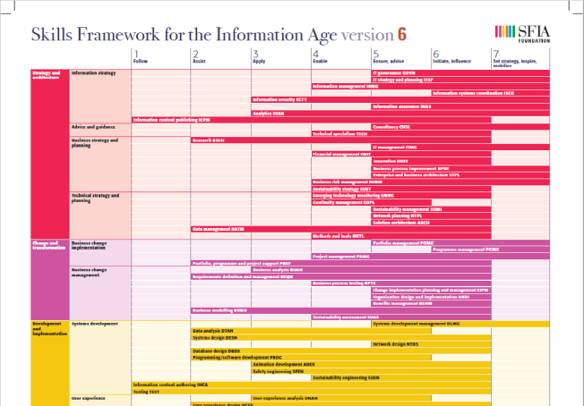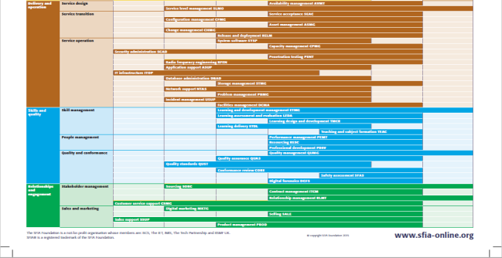
Fig 1-3 SFIA Framework

SFIA Framework ER Diagram (Fig 1-4) identifies the Skills entity, Levels Description entity, Levels of Responsibility entity and Levels Guiding Word entity. Skills entity is connected to Levels Description entity in 1: N by Skill code since a skill entry has multiple level descriptions. Levels Description entity is connected to Levels of Responsibility entity and Levels Guiding Word in 1: N (include0). For example, Skill name: IT governance, Skill code GOVN has Level 5, 6 and 7. So, GOVN corresponds to only these three Levels of Levels of Responsibility and Levels Guiding Word“Ensure, advise”,“Initiate, influence”,“Set strategy, inspire, mobilise”).

Fig 1-4 SFIA Framework ER Diagram

1.3 How SFIA Works – The SFIA Levels
The SFIA Levels describe experience and competency. The definitions describe the behaviors, values, knowledge and characteristics that an individual should have in order to be identified as competent at that level. Each level has a guiding word or phrase that acts as a brief indicator: FOLLOW • ASSIST • APPLY • ENABLE • ENSURE, ADVISE • INITIATE, INFLUENCE • SET STRATEGY, INSPIRE, MOBILISE. (Fig 1-5)
The SFIA Levels provide consistency for both the Generic Levels of Responsibility and the Professional Skills which should be used together.
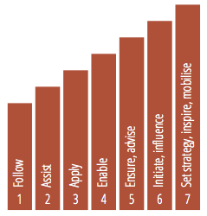
Fig 1-5 Levels of responsibility

1.4 Generic Levels of Responsibility
The generic levels of responsibility describe 4 attributes for each of the 7 levels and reflect the experience and competency levels within SFIA. An example is provided below (Fig 1.6)
The generic responsibilities are:
- Autonomy
- Complexity
- Influence
- Business Skills
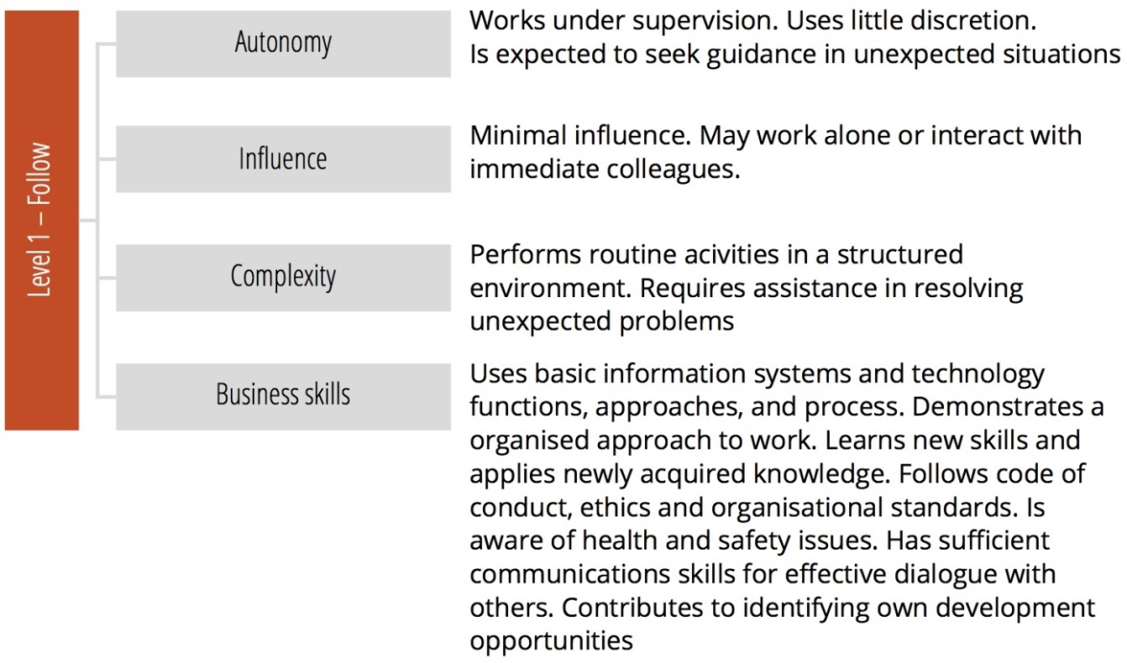
Fig 1-6 Example Generic Levels of Responsibility for a SFIA Level

1.5 Professional Skills
The SFIA Framework identifies 97 professional skills. Each skill entry comprises an overall definition and descriptions of each of up to seven levels at which the skill might be exercised. These descriptions provide a reference of how the skill and level combined produce a more detailed definition of what level of competency each skill is practiced at.
The Professional Skills are organized into 6 categories and a number of sub-categories. The categories and sub-categories do not equate to jobs, roles or organizational teams – they are there to for ease of use and aid navigation through the Framework.
The 6 categories are:
- Strategy and Architecture
- Change and Transformation
- Development and Implementation
- Delivery and Operation
- Skills and Quality
- Relationships and Engagement
As an example, a sub-category might be Business Change and Implementation that sits within Change and Transformation.

1.5.1 Consistent Layout of a Skill
The SFIA Professional Skills are described in a consistent manner:
- Skill Name
- Skill Code
- Skill Description
- Level Descriptors

A sample skills entry is shown below:
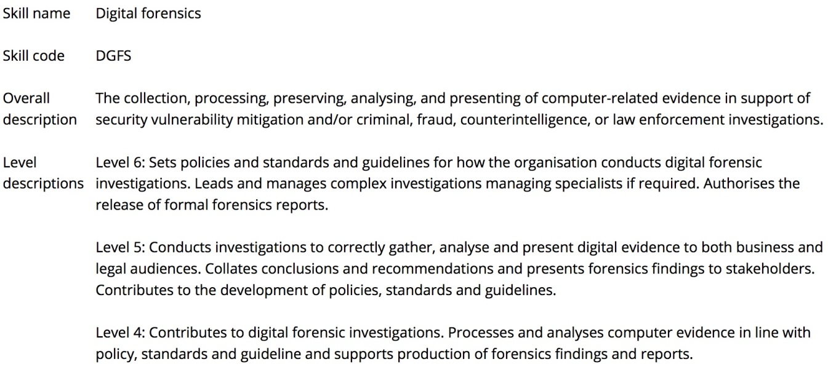

1.6 SFIA Documentation
The SFIA Framework is readily available online from the SFIA Foundation website and in two downloadable documents in six languages, with more translations planned:
- The Complete Reference Guide
This provides the detailed description of the Generic Responsibilities and Professional Skills, along with and introduction to the SFIA Framework, further explanation and a chapter on the wider use of the SFIA Framework.
- Summary Chart
This provides a summary view of the SFIA Generic Responsibilities and Professional Skills.

Current available documents relate to SFIA6 but will be replaced mid-2018 with updated SFIA version7 documentation.

2 i Competency Dictionary (iCD)

2.1 Overall

2.1.1 Background to i Competency Dictionary (iCD)
The i Competency Dictionary (iCD) is a structured dictionary, composed of the Task Dictionary and the Skill Dictionary, developed and maintained by the IPA (Information Technology Promotion Agency)^{*1} an organization governed by the Ministry of Economy, Trade and Industry of Japan.
The IPA developed the Common Carrier Skill Framework (CCSF) in 2008 by integrating three skill standards: ITSS （Information Technology Skill Standard）^{*2} 2002, UISS （User Information Skill Standard）^{*3} 2006, and ETSS （Embedded Technology Skill Standard）^{*4} 2005. The CCSF has been used as the skill standard for all business category organizations to adapt to rapidly changing business environment, also meeting the needs of IT human resources development.
Subsequently, the IPA reorganized and enhanced the CCSF, rebranded as the iCD trial version in July 2014, finally releasing version 1 of the iCD2015 in June 2015.
*1: For more information about IPA, visit IPA website at https://www.ipa.go.jp/index-e.html
*2: Skill standard for the vendors in IT service industry to develop IT human resource.
*3: Skill standard for IT user organization IS human resource development.
*4: Skill standard for human resource development engaged with embedded software development.

2.1.2 Update Process
Since its 2005 release, the iCD has been updated annually, ensuring its ongoing relevance. The annual update process is planned to continue, taking into consideration:
- The voices / opinions of users or stakeholders
- Global IT trends captured through various collaborations
- The need for consistency between IT Engineer Examination (ITEE) updates and the iCD
- Updates of other global standards and BOKs available in Japanese

2.1.3 iCD Contents
The iCD consists of the task dictionary and the skill dictionary (Figure 2-1). The task dictionary specifically details task requirements in IT business, and the skill dictionary details the IT skills required to perform those tasks. In the iCD, a task identifies a function of the IT organization and is equivalent to a specific job, while a skill means the ability to handle knowledge. The iCD contains the essential elements from the three previous skill standards in Japan.
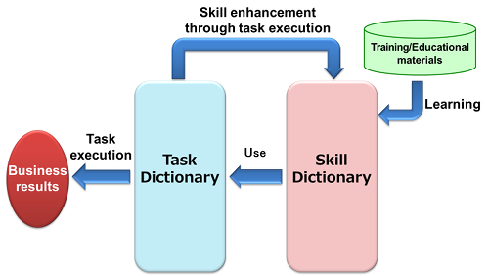
Figure2-1 Relationship between Task execution and Dictionaries
Table 2-1 shows the list of iCD main contents.
Table2-1 iCD main contents list
 | name | Description
1 | Task List | The list of tasks. The Task Dictionary is comprised of 4 layers divided into three task layers plus the Assessment Items layer (approx. 2,200 items).
2 | Task Dictionary Chart | Task Dictionary overall view
3 | Task Profile | A list of profiles and explanations by business types, development targets, development methods and roles.
4 | Task Profile X Task Corresponding table | The corresponding table between an entry of the task profiles and tasks in the task list
5 | Skill List | The list of skills. The Skill Dictionary is also comprised of 4 layers divided into three skill layers plus BOK layer (approx. 10,000 items).
6 | Skill Dictionary Chart | Skill Dictionary overall view
7 | Job List | The list of job professions and explanations
8 | Job X Skill Corresponding table | The corresponding table between each job in the job list and skills
9 | ITEE X Skill Corresponding table | The corresponding table between each ITEE and required skills with required level
10 | Task X Skill corresponding table (Second layer) | The corresponding table between tasks and skills (2nd layer basis)
11 | Task X Skill corresponding table (Third layer) | The corresponding table between tasks and skills (3rd layer basis)

The Entity Relationship Diagram of the iCD is illustrated in Figure2-2
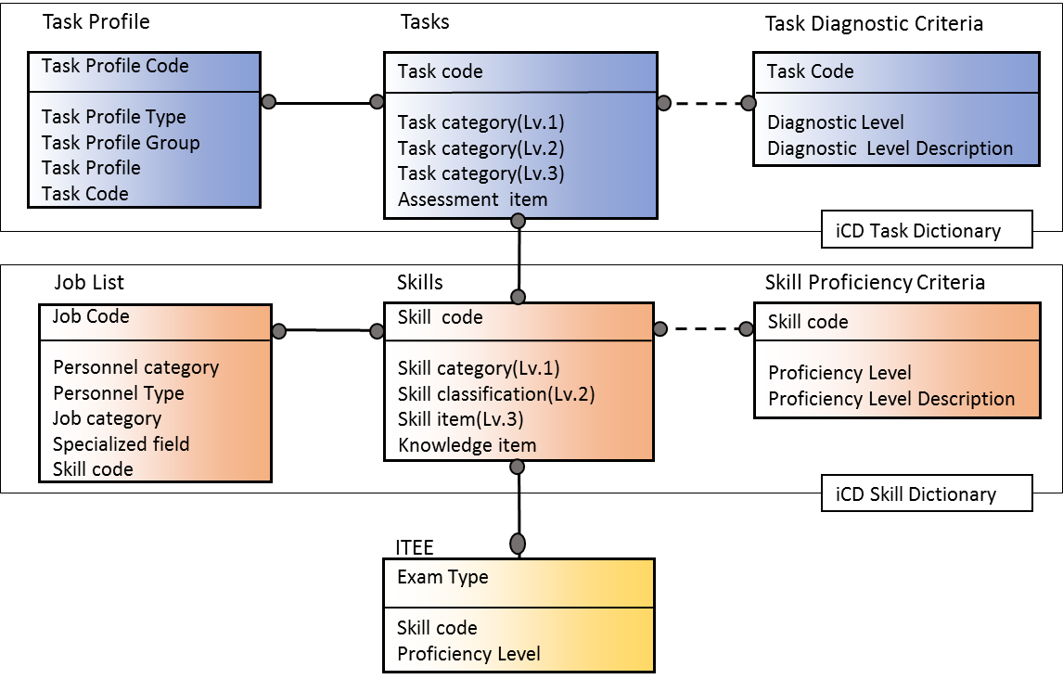
Figure2-2 i Competency Dictionary (iCD) ER Diagram
In Figure 2-2, the ITEE refers to the IT Engineer Examination, a large national examination in Japan with approximately 600,000 applicants annually. Conducted by the IPA since 1969, the ITEE consists of 13 examination categories aligned with 4 levels. The ITEE is well respected and supported by the industry and academia, and many IT companies recommend their employees obtain the qualification in their HR development system.

2.1.4 iCD Implementation Status
By September 2017 about 1000 organizations had the iCD user company certification. HITACHI Ltd is the largest, using iCD tasks to perform level checks for 20,000 employees.
Companies and organizations use the Task Dictionary to determine internal tasks in line with their business strategy or business plan and it is, therefore, predominantly used in Industry. However, iCD implementation is also making progress within academia, such as university IT departments and IT engineer education schools; within these organizations, the Skill Dictionary is mainly used to establish a syllabus or curriculum for IT engineering. The IPA welcomes this particular trend, which demonstrates the iCD’s wider acceptance.
The iCD has seen an increase in interest and take-up around the world since the English version was released in 2015 (Europe, Middle East, Asia, and North/South America) and to-date, 24 countries have adopted the iCD.

2.1.5 iCD Supplement
The iCD Task Dictionary comprises the Main contents and Supplementary contents. Only the Main contents have been translated into English for overseas use as the Supplementary contents relate specifically to urgent or special task requests from Japanese companies. The Supplementary contents are not linked to skills and currently support consideration of the following tasks:
- Marketing
- General affairs/Personnel affairs/Accounting
- Education
- Call centers
- IoT system service lifecycle

2.2 Task Dictionary and Structure
The Task Dictionary is a four-layer structure (Figure 2-3) where tasks are broken down in detail from major to minor through the layers. Organization members typically evaluate task performance based on allocated third layer (minor) tasks, with the fourth layer (Assessment Items) offering further explanation. Organization members may also choose to evaluate task performance in the second layer, rather than in the third, thereby avoiding too much detail.

2.2.1 Task Dictionary Overview
The iCD Task Dictionary (Figure 2- 3) provides a comprehensive grouping of tasks which can be used by, and applied to, a wide range of companies and organizations due to the referencing of the following task models:
- Japan Common Frame 2013 (SLCP 2013), which is defined by analyzing and integrating software life cycle standards such as ISO/IEC 12207, 15288 and 29148
- ITIL V3: Reference information for tasks related to IT service management, system operations management, etc.
- COBIT 5: Reference information for tasks related to IT governance
- Embedded System Development Process Reference (ESPR Ver. 2.0)
- CRISP-DM: Reference information for tasks related to data science

The iCD, therefore, provides the standard reference to understand the relationships between various BOKs, skill standards, and the ISO software life cycle process standards.

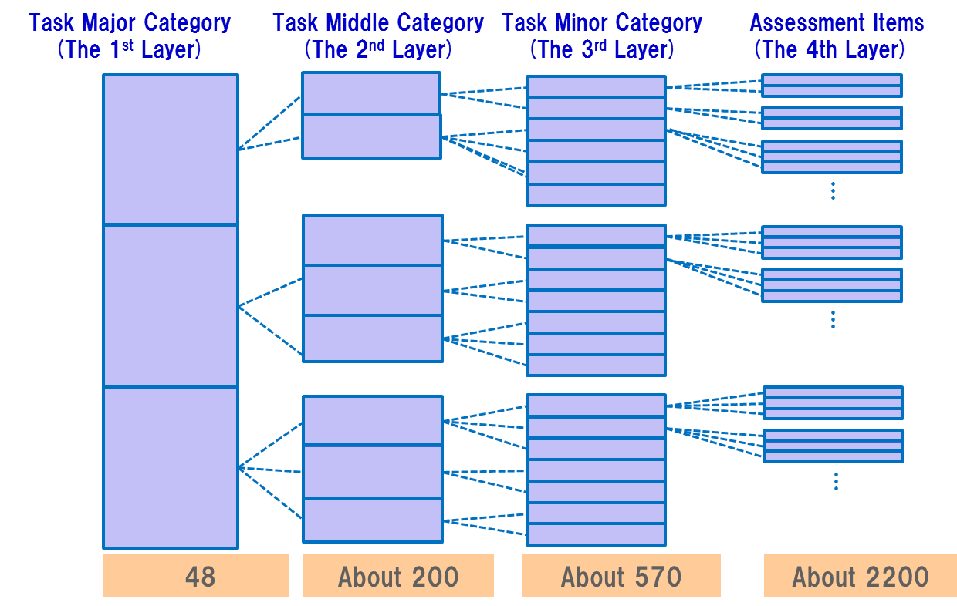
Figure 2-3 iCD Task Dictionary Structure

2.2.2 Task Dictionary Structure
The Task Dictionary structure represents the Organizational Structure and Function of IT in Business and has a four-layer structure:
- Major Task category (1st layer) represents Organizational Structure.
- Middle Task category (2nd layer) represents Organizational work list.
- Minor Task category (3rd layer) represents greater details of the Middle Task category.
- Assessment Items (4th layer) provides deeper explanation of the Minor Task category.

2.2.3 Task Categories
Tasks are detailed on the horizontal axis and the vertical axis (Figure 2-4). The vertical axis shows the lifecycle of the IT business, and the horizontal axis details the lifecycle support tasks:
- The vertical axis indicates the five categories of the IT business lifecycle process, namely:
Strategy：Formulates the business strategy for IT business operations, products, and services.
Planning：Based on Strategy, formulating operations or business implementation plans to utilize IT.
Development：Based on Planning, developing various products or services.
Utilization：Using various products or services.
Evaluation/Improvement：Based on Utilization results to evaluate Strategy, Planning, and extracting improvement items (task sets) for the next fiscal year.
- The horizontal axis shows the three areas of the IT business lifecycle process, namely:
Planning and Execution：Tasks to plan and achieve IT business (PDCA cycle).
Management and Control：Tasks to manage and control the Planning and Execution tasks across the whole IT business lifecycle process.
Promotion and Support：Tasks to promote or support Planning and Execution tasks.

Plan
Check/ Action
Do
Work with Planning & Execution tasks as necessary
Manage or Control across whole Planning & Execution tasks

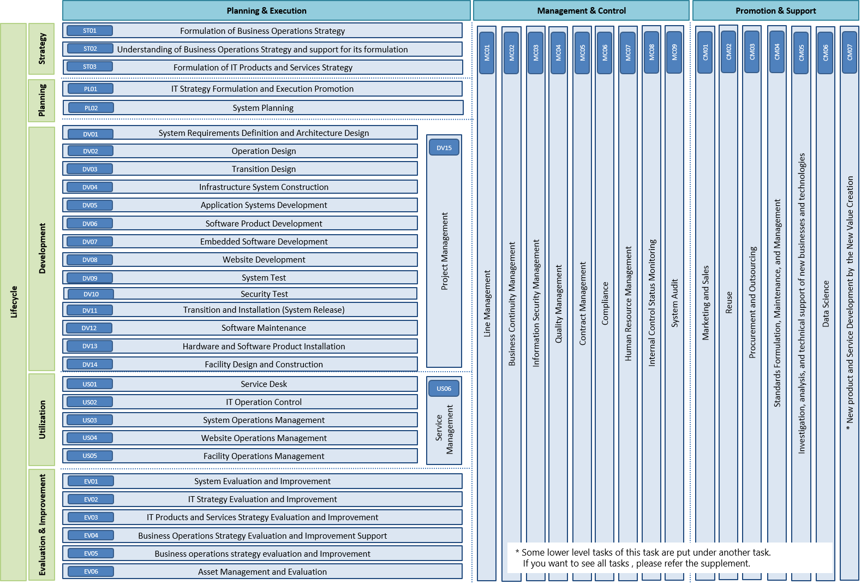
Figure 2-4 Task Dictionary Categories

2.2.4 Major Task Category
The Major Task Category (1st layer) defines generic organizational structure. These tasks are the functions most commonly undertaken by any organization and, therefore, specific viewpoints such as business type or position are not included. In addition, tasks undertaken in relation to the user’s requirements, such as business models, business types, or development methods, are defined in the remaining layers, 2 through to 4.

2.2.5 Middle Task Category
The Middle Task category (2nd layer) defines tasks in respect of departmental role. The definitions for the Middle Task layer are:
- Tasks that differ according to business type/position become 'different' tasks.
- Tasks that are the same despite differing business types/position become 'same' tasks.
Table 2-2 summarizes these policies.
Table 2-2 Summary of Task 2nd layer definition policies
Business Type/position  Action | Same | Different
Same | Same Task | Same Task
Different | Different Task | Different Task

2.2.6 Minor Task Category & Assessment Items
- The Minor Task category (3rd layer) represents the Middle Task category in greater detail.
- The Assessment Items (4th layer) represent a deeper explanation of the Minor Task category, and the practical application of 3rd layer tasks are also described in this layer to aid understanding.

2.3 Task Profiles
The Task Profiles provides additional task information to enable organizations, businesses, and companies to formulate their own task sets. The documentation includes: the descriptive List of Task Profiles, and the Task Profile × Task Correspondence Table. The profiles are classified based on task features and characteristics such as their corresponding business/function or development target:
- Business Type
Examples of task sets that may be necessary depending on the organization's type (user, vendor) or business category, such as internal information systems development, maintenance, operations, software product development, system operation services, etc.
- Development Target
Examples of task sets that may be necessary depending on the type of target for development, construction, maintenance, or operation, such as application systems, infrastructure systems, embedded software, etc.
- Development Method
Examples of task sets that may be necessary depending on the type of development methods such as Waterfall, Agile, etc.
- New Business
Examples of task sets that are essential to the personnel who will take on new business and functions such as cloud business, data science, information security, etc.
- Role
Examples of task sets used by companies or organizations when determining their own roles. Companies and organizations can use the Role-Based Task Profiles as a reference in selecting essential tasks based on their own business or functions.

2.4 Task Assessment Level
The Diagnostic Criteria can be applied to the Task Assessment items or the appropriate task layer to evaluate an individual's task performance level from L0 to L4 (Table 2-3). This Diagnostic Criteria can initially be applied to the individual task assessments, then the task performance for each department or an organization can be obtained by aggregating all results. Table 2-3 shows an example of the Task Assessment Diagnostic Level and Diagnostic Criteria.
Table 2-3 Examples of Task Assessment Diagnostic Level and Diagnostic Criteria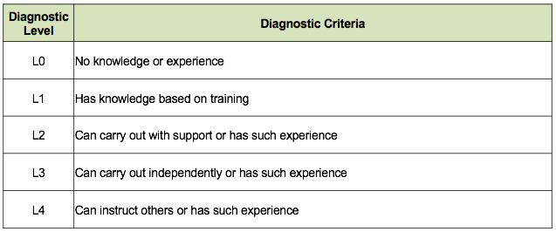

2.5 Skill Dictionary and Structure
Skills are the capabilities required to handle the necessary knowledge items in order to carry out a task. The Skill Dictionary comprises four layers divided into three skill layers plus a fourth layer of approximately 10,000 Associated Knowledge Items (Figure 2-5). The Skill Dictionary references and sorts items from the major Body of Knowledge, processes and skill standards in the world.
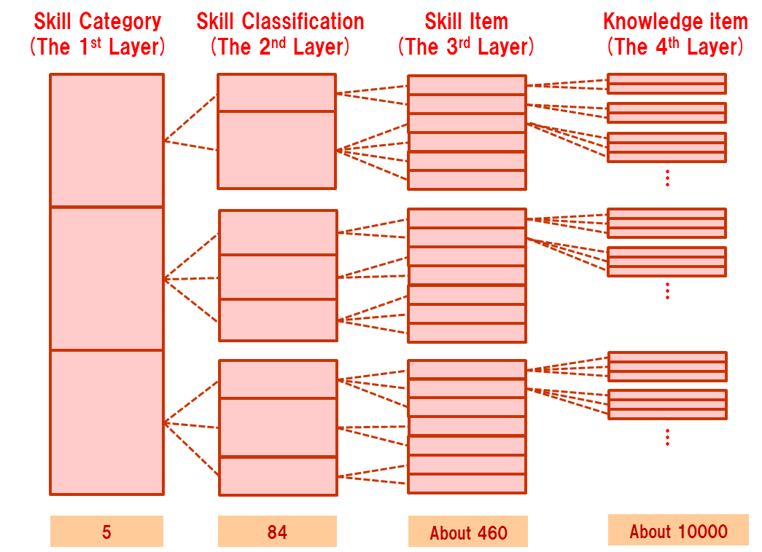
Figure 2-5 The iCD Skill Dictionary Structure

2.5.1 Skill Dictionary Overview
The iCD Skill Dictionary has been compiled by analyzing various tasks, skills and knowledge items as defined in the following list of BOKs and skill standards (ITSS, ETSS, UISS). J07 is a collection of six BOKs developed by the IPSJ (Information Processing Society of Japan) for college-level computing education. The iCD Skill Dictionary also contains IT soft skills such as creativity, execution & practice, and communications.
- BABOK (Business Analysis)
- CBK (Information Systems Security)
- CCSF (Common Career/Skill Framework)
- DMBOK (Data Management)
- JITEE (Japan IT Engineer Examination)
- ITIL
- ITS (IT Specialist Training Handbook)
- Computing Curriculum Standard J07
- PMBOK (Project Management)
- REBOK (Requirement Engineering)
- SABOK (Strategy and Analysis)
- SQuBOK (Software Quality)
- SWEBOK (Software Engineering)
- ITSS (IT Skill Standard)
- ETSS (Embedded Technology Skill Standard)
- UISS (User’s Information Systems Skill Standard)
- SecBoK (JNSA)
- (CAIS)BOK (JASA)

2.5.2 Skill Dictionary Structure
The Skill Dictionary is a four-layer structure (Figure2-5) that has been built from the expansive fourth layer upwards. The iCD refers to the fourth layer as the body of knowledge (BOK) that has been collected and collated from a variety of national and international BOK sources. These BOKs integrate into the third level (Skill Item), then into the larger second level (Skill Classification), and, finally, into the first level (Skill Category).

2.5.3 Skill Category
Skill category is the highest layer of skills: Technology, Methodology, Related Knowledge, IT Human Skill, Specific Skill. Table 2-4 shows the meanings of each category.
Table 2-4. Skill categories (1st layer) description
Skill Category（1st layer） | Description
Technology | Technical skills to accomplish tasks. These generic skills apply to all users.
Methodology | Methods, methodology, solution methodology skills to accomplish tasks. These skills work differently depending on users.
Related Knowledge | Skills related to fields other than methodology and technology that is applied to various aspects of IT business activities.
IT Human Skill | Human skills to accomplish tasks. The ability shown in various situations of IT business activities.
Specific Skill (Option) | Each organization can define skills originally. IPA provides conceptual area only (therefore, initial status is blank)

2.5.4 Skill Classification
The 3rd layer, Skill Classification details 84 skills, and the use of these can broadly define an individual's skill set.

2.5.5 Skill Item / BOK
The 84 Skill Classifications are explained in greater detail in Skill Item, for example, the classification (Implementation) Architecture design method consists of five Skill Items as expressed in table 2-5. This particular skill level would apply to students or elementary learners.

Table 2-5. Skill Dictionary 2nd layer and 3rd layer example
Skill Classification | Skill item
（Implementation）Architecture design method | Architecture design method
（Implementation）Architecture design method | Application Architecture design method
（Implementation）Architecture design method | Industry package design/development method
（Implementation）Architecture design method | Infrastructure architecture design method
（Implementation）Architecture design method | Data architecture design method

Knowledge items (4th layer) can be used to more deeply understand the meanings of a practical skill item, for example, Table 2-6 shows the skill item 'Infrastructure architecture design method', which details 17 knowledge items, from K001 to K017, to assist in the understanding.

Table 2-6 Skill dictionary 3rd layer and 4th layer example
Skill item | Code | Knowledge item
Infrastructure architecture design method | K001 | System management / operation
Infrastructure architecture design method | K002 | System management / operation design
Infrastructure architecture design method | K003 | Evaluation of system infrastructure test strategies and plan
Infrastructure architecture design method | K004 | Evaluation of system infrastructure transition strategies and plan
Infrastructure architecture design method | K005 | Evaluation of system infrastructure design tools
Infrastructure architecture design method | K006 | Evaluation of system infrastructure design techniques
Infrastructure architecture design method | K007 | Security
Infrastructure architecture design method | K008 | Security design
Infrastructure architecture design method | K009 | Network
Infrastructure architecture design method | K010 | Network design
Infrastructure architecture design method | K011 | Performance design
Infrastructure architecture design method | K012 | Platform
Infrastructure architecture design method | K013 | Platform design（OS, middleware etc.）
Infrastructure architecture design method | K014 | Availability design
Infrastructure architecture design method | K015 | Performance and capacity
Infrastructure architecture design method | K016 | Knowledge of target domain
Infrastructure architecture design method | K017 | Physical data structure design, etc.

2.6 Job List
The Job List includes the professions involved in IT business and shows the mandatory skill items of the Skill Dictionary for the profession (Figure2-6). It is expected to be used as a reference resource to help IT engineers set their own targets and identify the skills necessary for those targets.
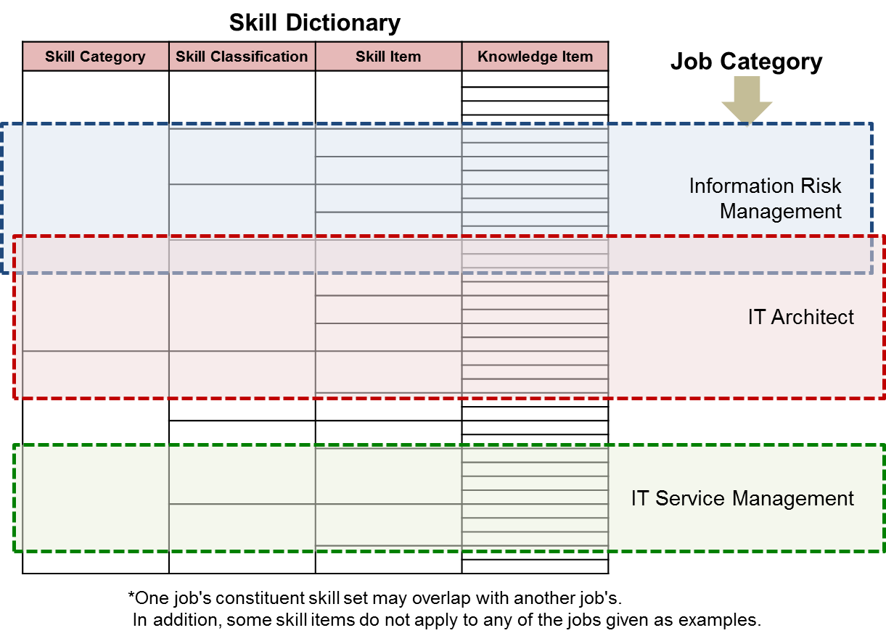
Figure2-6 Examples of Overlapping Skill Sets

2.7 Skill Proficiency Criteria
The Skills Proficiency Levels chart (Figure 2-7) measures the skill proficiency level using the skill proficiency criteria of seven levels. The criteria of Levels 1 to 4 differs according to the contents of technology, methodology and related knowledge. Skill proficiency Level 4 is the highest acquisition level of the skill for task accomplishment; Levels 5 to 7 are defined across the categories evaluating professionalism by social contribution.
Figure 2-7. Skill Proficiency Levels

2.8 Task x Skill Correspondence Table
Figure 2-8 indicates with a dot in applicable cells those skills that are associated with particular tasks. Displayed below is an example extract of the complete table. This table is used to identify the skills corresponding to each task and vice versa.

Figure 2-8. Task X Skill Table (extract)

2.9 The iCD Application System
The IPA provides the Application Service Provider (ASP) system to promote iCD utilization. It is free for use but available only in Japanese. More information can be found at this website:
https://www.ipa.go.jp/jinzai/hrd/i_competency_dictionary/system.html

2.10 iCD Documentation
To request the full iCD, visit the IPA web site (https://www.ipa.go.jp/english/humandev/icd.html) and once the application form has been completed, the full iCD will be sent as e-mail attachment. The material and content of the full iCD are shown in the table 2-7.

Table 2-7 iCD Documents
Material | Content
Task Dictionary Chart | Task Dictionary overall view
Task Dictionary | Task list and associated materials
Skill Dictionary Chart | Skill Dictionary overall view
Skill Dictionary | Skill list and associated materials
Task x Skill corresponding table | Task vs Skill relationship matrix
Handbook | iCD usage explanation guide

3 SFIA & iCD Comparison of Underlying Principles

3.1 SFIA & iCD Overall Comparison
A comparison between SFIA and the iCD in areas including organization, structure, design principles etc., appears in Table 3-1.
Table 3-1. Overall Comparison between SFIA and the iCD
 | SFIA |  | iCD
Background | SFIA originated out of the collaboration of skills and competency initiatives within UK companies in the 1980s and 90s.  This collaboration resulted in the single skills framework (SFIA) being published and adopted within the UK, and made available through the SFIA Foundation from the year 2000.  Since 2003 the SFIA Framework has been the single global common language for describing skills and competencies required in the digital world.  Adoption of SFIA increased steadily in the early years, firstly in the within the UK, and subsequently, globally. |  | The IPA has used three skill standards ITSS (Information Technology Skill Standard) from 2002, UISS (User Information Skill Standard) from 2006 and ETSS (Embedded Technology Skill Standard) from 2005 and integrated these into the Common Carrier Skill Framework (CCSF) in 2008.  The IPA enhanced the CCSF and reorganized it into the iCD trial version in July 2014, then released iCD2015 in June 2015 as the first version. Adoption of the iCD in Japan has increased rapidly.  The iCD English version was released one year after the Japanese version:  -English iCD Trial version Jun/30/2015  -English iCD V1 Jul/15/2016  -English iCD V2 Apr/12/2017
Organization | The SFIA Foundation (Fig 1-1) is a global not-for-profit organization that develops, maintains and makes available the SFIA Framework for use. It is funded through a modest licensing model for use of the SFIA Intellectual Property – with the vast majority or users able to use SFIA under a free-of-charge user license.  The work of the Foundation is overseen by the SFIA Board which focuses on governance and oversees the work of the Foundation, while a modest operations and business administration activity carries out the day-to-day running of the Foundation. The SFIA Council, comprising representatives from the global user base, discusses the Foundation's direction, providing a pool of expertise. Finally, the global SFIA community of users is able to suggest input into updated versions of the SFIA Framework and associated products, which are then agreed and published by the SFIA Foundation Design Authority.  What is perhaps unique about SFIA is the way it has focused on mobilizing the global user base to balance the needs of all stakeholders rather than to be overly driven by any one and this is a major component of its success – it is 'pulled' by industry and business because they want it rather than 'pushed' by any commercial or other interests.  For more information about the SFIA Foundation, the SFIA Framework or how the framework can be used visit the SFIA Foundation website at www.sfia-online.org or contact the SFIA Foundation General Manager, Ian Seward, at ops@sfia-online.org |  | The iCD is developed and maintained by the IPA. The IPA has promoted activities related to IT policy since its establishment in 2004 as a policy implementation agency under the  jurisdiction of the Ministry of Economy, Trade and Industry (METI).  The IPA looks at the bigger picture of IT in society, endeavoring to meet the challenges of creating a safe and convenient use of IT in society, today and in the future. The way society interacts with IT has changed significantly in recent years due to the progress of the IoT, which will connect everything to the Internet, also the rapid improvement of big data technologies, and the rise of artificial intelligence. The IPA's contribution aims to solve problems, making IT in society reliable by through IT Security, IT Human Resources Development, and the Development and Promotion of Reliable Systems.  There are plans to establish the iCD Association (iCDA), a not-for-profit organization, in 2018. Its mission will be:  1. Support iCD implemented companies  2. Certificate iCD implemented companies/organizations to promote iCD  3. Promote iCD System Utilization  4. Construct the iCD Education System using iCD  The IPA will be responsible for maintaining the iCD and iCDA will be in charge of iCD marketing.
Structure | The SFIA Framework is simple and generic and, like all frameworks, has a structure that is consistently applied throughout the Framework: this allows information to be readily found and considered consistently (Fig 1-3).  Essentially, the SFIA Framework is a 7 level framework with 4 generic responsibilities, and 97 professional skills aligned to the 7 levels; the generic responsibilities and professional skills are used together  The SFIA Framework consists of Skills, Levels Description, Levels of Responsibility, and Levels Guidance from ER Diagram (Fig 1-4). The Skills entity is connected to the Levels Description entity in 1: N by Skill code since a skill entry has multiple level descriptions. Levels Description entity is connected to Levels of Responsibility entity and Levels Guiding Word in 1: N (include0). For example, Skill name : IT governance, Skill code GOVN has Level 5, 6 and 7. So, GOVN corresponds to only these three Levels of Levels of Responsibility and Levels Guidance ( “Ensure, advise”, “initiate, influence”, “Set strategy, inspire, mobilise”). |  | The iCD consists of the Task Dictionary and the Skill Dictionary (Fig 2-1).  The Task Dictionary is a four-layer structure (Fig 2-3). A task increases in detail from the first layer to the second layer and to the third layer. Organization members evaluate the task performance typically based on allocated third layer tasks. The fourth layer (Assessment items) explains the meaning of third layer tasks.  The Skill Dictionary is a list of capabilities required to handle associated knowledge items to carry out tasks. The Skill Dictionary is a four-layer structure (Fig 2-5) divided into three skill layers plus Associated Knowledge Items (approx 10,000). The Skill Dictionary references and sorts the items from the major global Body of Knowledge (BoKs).  The Task Dictionary has Main and Supplementary contents. Only the Main contents has been translated to English because the Supplementary contents comprise only urgent or special task requests from Japanese companies and are not linked to skills. The current supplementary contents include:  ・ Marketing  ・ General affairs/Personnel affairs/Accounting  ・ Education  ・ Call center  ・ IoT system service lifecycle
Design Principles | The SFIA design principles were established in 2000 and are regularly revised to ensure they remain relevant. These design principles have enabled SFIA to resist following latest trends, and to focus on transferrable skills, allowing experience to be valued and individuals to maintain relevance in the work place.  One design principle, for instance, Method and Technology Independence, means that a particular method or technology is not the driver, rather the skill is the driver; and programming, for example, is the skill, Java or C++ is the technology, and while the language in this case may be relevant to a particular job, the skill is, nevertheless, programming. This is an important point as while the industry moves rapidly and new methods or technologies appear frequently, many skills persist throughout and SFIA recognizes this. |  | The Task Dictionary is intended to be used and applied by companies and organizations in order to determine tasks in line with business strategies or business plans, and therefore, the Task Dictionary is used widely in Industry.  The Skill Dictionary, however, is used by academic organizations such as IT departments in universities and IT engineer education schools to setup their syllabuses or curriculums.  Tasks and skills are connected so skills to enhance tasks can be identified in industry, and students can identify tasks using acquired skills.  The IPA is responsible for the IT Engineer Examination (ITEE) and the iCD provides the link between each ITEE examination and required skills and levels.
Update Process | The SFIA Framework is updated by a process of open consultation involving the whole user-base: anyone can raise a request for change and these are reviewed against the SFIA design principles and progressed accordingly by the Design Authority. New or updated content is drafted by the volunteer user community and reviewed. Then the draft of the whole framework is assembled and reviewed again for consistency across skills and against design principles, translated and published by the Design Authority. |  | Since the first version was released in 2015, the iCD update has been reviewed annually. This annual update process is planned to continue. Update consideration points include:  ・The voices/opinions of users or stakeholders  ・Global IT trends captured through various collaborations  ・The consistency between the ITEE updates and the iCD  ・Updates to recognized global standards and BOKs
Update Frequency | Updates occur every 2-3 years leading to the publication of new version (SFIA version 7 publication due mid-2018) |  | The Japanese version is updated annually; the English version is updated annually and published one year later than the original Japanese.
Translation | Available in 6 languages (English, Spanish, German, Japanese, Chinese, and Arabic) with more planned. |  | Available in 2 languages (Japanese and English) with no plan for other translations.
Usage | SFIA has a world-wide user-base of thousands of organizations and individuals in around 160 countries. As of 2017, there are some 20,000 users: a single user may be using SFIA across a workforce of thousands. The SFIA Framework has become the de facto global IT skills framework, a global common language, and a standard for skills and competencies. |  | About 1000 organizations in Japan have achieved corporate iCD user certification (Sept 2017). HITACHI Ltd is the biggest iCD user, using iCD tasks to perform level checks of 20,000 employees.  Since the 2015 release of the English version use of the iCD has grown around the world: Europe, Middle East, Asia, and North/South America and has been adopted by 26 countries (2017).
Price | Free to use but charges apply according to type of usage, commercial, for instance. |  | The iCD system and contents are free to Japanese users.
Global Status | Due to the global reach and influence of SFIA, many organizations have approached the Foundation for international collaborations.  SFIA is a global phenomenon and the de facto global IT skills framework – it has done this without any push from the Foundation, any organization, or any Government. To have achieved this without any well-resourced central drive or promotion is remarkable and is as a result of a number of key attributes:  1. The Framework must be right: it is used because companies and individuals want to effectively manage the skills and competencies of self/staff and find it helpful and relevant.  2. It reflects reality and is relevant to industry and business. It is built by industry and business for use by industry and business and focuses on the needs of the end user rather than other interested stakeholders alone.  3. It is simple, generic, independent of method or technology, extensive and universally applicable.  4. It requires experience of a skill to be demonstrated. An individual has the skill at a particular level because they have performed that skill, at that level, in real-world situations.  5. It is readily available. It can be obtained free of charge and is available in 6 languages.  6. An ecosystem has been established and this now provides support for all users.  While there are many other attributes that have contributed to the success that is SFIA these are perhaps the key elements. |  | The iCD collaborates with several global organizations:  [IEEE-CS]  ・Contracted MoU in June 2016 in Global Alliance Membership of IEEE-CS.  ・IEEE-CS EITBOK（April 2017) refers the iCD to show the relationship between EITBOK activities and the iCD tasks and skills on EITBOK wiki.  [ACM]  ・The IPA is a member of the Task Group of the CC (Computer Curriculum) 2020 project  ・Thesis submitted about iCD jointly  [ATD (Association of Talent Development)]  ・Submitted iCD lecture to ATD Asia Conference 2015 in Taipei together with presentation of the iCD.  [SFIA]  ・Contracted MoU (Sept 2017) for SFIA and the iCD Comparison Research Project.  ・In this project, the structures of SFIA and the iCD are being compared, to be followed by the mapping of SFIA skills and iCD tasks. This project's duration will be two-and-a-half years.  [IVI]  ・Contracted iCD Licensing in Feb 2017.  ・IVI uses IT-CMF to diagnose IT capability maturity of companies then uses the iCD to improve the competency of employees.  [Others]  ・The IPA is a member of ITPE (IT Professionalism Europe), which is an initiative of CEPIS (Council of European Professional Informatics Societies).
Public Activities | Not at present although future activities are under consideration. |  | ・Workshops at various venues within Japan  ・Monthly iCD Explanation Sessions at the IPA  ・The annual iCD Conference in Tokyo
Documents | The SFIA Framework is readily available online from the SFIA Foundation website in two downloadable documents:  • The Complete Reference Guide (SFIA6)  This provides the detailed description of the Generic Responsibilities and Professional Skills, along with an introduction to the SFIA Framework, further explanation and a chapter on the wider use of the SFIA Framework.  • Summary Chart (SFIA6)  This provides a summary view of the SFIA Generic Responsibilities and Professional Skills. The SFIA materials are currently available in 6 languages with other translations planned.  The updated SFIA (version 7) will be published mid-2018. |  | The full iCD is downloadable from the IPA website: (www.ipa.go.jp/english/humandev/icd.html). Following completion of the online application form, the full iCD contents are sent by e-mail.  As shown in table 2-1, the iCD provides the following contents:  ・Task List  ・Task Dictionary Chart  ・Task Profile  ・Task Profile ×Task Corresponding Table  ・Skill List  ・Skill Dictionary Chart  ・Job List  ・Job × Skill Corresponding Table  ・ITEE × Skill Corresponding Table  ・Task × Skill Corresponding Table  In addition:  ・i Competency Dictionary Handbook  ・iCD Pocket Handbook
System | None |  | The IPA provides the Application Service Provider (ASP) system to promote the iCD utilization. It is free to use but only available in Japanese. More information:  www.ipa.go.jp/jinzai/hrd/i_competency_dictionary/system.html"

3.2 SFIA & iCD Detailed Comparison

3.2.1 SFIA and iCD Relationship
The Complete Reference Guide (currently SFIA6) provides detailed descriptions of Generic Responsibilities and Professional Skills, along with an introduction to the SFIA Framework, further explanation, and a chapter on the wider use of the SFIA Framework.
- SFIA is a practical resource for individuals who manage or work in IT. It provides a common reference model in a two-dimensional framework consisting of skills on one axis and seven levels of responsibility on the other. It describes professional skills at various levels of competence, also generic levels of responsibility in terms of Autonomy, Influence, Complexity and Business Skills. (P 8/85, SFIA6 Complete Reference Guide).
- SFIA is used extensively in the assessment of existing capability, at individual and organizational levels. The framework itself does not provide instructions for improvement or the specific mix of skills that an individual or organization should have. Context is important in the use of any framework, and it is crucial to understand an organization’s needs rather than simply use the skills in an isolated way to form a single job description or role profile. The specific mix will be different from one organization to the next. (P 13/85, SFIA6 Complete Reference Guide).
- SFIA does not attempt to cover all individual requirements and does not describe any specific product, technology, skills or knowledge, industry experience or qualifications. For example, a service desk manager could be considered to require knowledge of a particular process framework (such as ITIL or COBIT), together with specific service desk tools used in that particular organization, also specific industry experience, security clearance and defined qualifications. (P 13/85, SFIA6 Complete Reference Guide).
The iCD comprises the Task Dictionary and the Skill Dictionary. A task specifically means a function of an organization. In other words, a task is a work the organization should do, but a task has no concept of order a work has. Although the Task Dictionary shows tasks in a sequence, these are listed purely for convenience of arrangement and in no particular order. A task is simply a function to accomplish without any prerequisite skills implication.
The Skill Dictionary indicates the skills required in order to accomplish tasks. Skills for a task are mapped in the task×skill matrix, and the prerequisite skills for the task are identified by this matrix. In the Skill Dictionary, skills required for any task are comprehensively defined. 'Skill' is the ability to handle or make use of knowledge items (skill dictionary 4th layer) and these abilities are listed in the 3rd layer. They are suitably grouped into the 2nd layer and 1st layer. A skill can be mapped to multiple tasks to be able to be required by multiple tasks.
SFIA is a simple, generic, and universally applicable skills and competency framework. It recognizes the importance of technology, knowledge and qualifications but deliberately does not specify these as they rapidly change, sometimes by trend alone. This is similar to the task definition in the iCD which is just the function definition independent of skill (Fig 3-1. SFIA Skill and iCD Task Dictionary Relation).

Figure 3-1. SFIA Skills and iCD Task Dictionary Comparison
A direct comparison between SFIA and the i-CD can be considered at a point where SFIA Skills corresponds to the iCD Task Dictionary.
- Skills Definition in SFIA
In SFIA, Overall Skills is described as: 'A broad definition of the skill, without any reference to the levels at which it might be practiced, (p 13/85, SFIA6 Complete Reference Guide).
And, the overall description of Systems Design (DESN) is as follows:
The specification and design of information systems to meet defined business needs in any public or private context, including commercial, industrial, scientific, gaming and entertainment. The identification of concepts and their translation into implementable design. The design or selection of components. The retention of compatibility with enterprise and solution architectures, and the adherence to corporate standards within constraints of cost, security and sustainability.

Figure 3-2. SFIA SKILLS: An Overall description of System design (DESN)

- Task Definition in the iCD
The corresponding definition in the iCD Task Dictionary is looked at in detail: as an example, an extract of Layer 1 System Requirements Definition and Architecture Design (Major Task Category) is expanded to Layer 2 (Middle Task Category), Layer 3 (Minor Task Category) and Layer 4 (Assessment Item):
- System Requirements Definition and Architecture Design
2. System requirements definition
3. Target and objectives determination of the system
4. Understand the problems and needs of the user from a user business perspective
4. Build a hypothesis of relationships and gaps between user needs and the current system
4. Identify the operations and system to be computerized based on the presented computerization plan
3. Investigation and analysis of requirement
4. Analyze current system based on system usage/usability/hardware configuration/software configuration/data configuration/operation management, etc.
4. Establish and investigate items for understanding other functions and systems linked to the target scope in order to clarify the computerization requirements
4. Establish and investigate items for understanding the target scope in order to clarify the computerization requirements
4. Investigate technologies and products that are intended to be used in the computerization in order to understand functions, constraints, and risks
3. Functional requirements definition
4. Define requested functions or requests regarding them in the form of requirements that a system should meet
4. Actualize usability requirements based on the current system issues and user needs
4. Present an implementation scheme for the functional requirements
4. Calculate the cost for implementing functional requirements
4. Identify the restrictions related to functional requirements
3. Non-functional requirement definition
4. Define requests regarding availability, performance and scalability, operability and maintainability, portability, security, and system environment and ecology in the form of non-functional requirements that a system should meet
4. Present an implementation scheme for the non-functional requirements
4. Calculate the cost for implementing non-functional requirements
4. Identify the restrictions related to non-functional requirements
3. Documentation and review of system requirement
4. Consolidate computerization targets, objectives, requirements (functional and non-functional) and constraints in a computerization requirements definition document and explain them to the relevant parties
4. Evaluate the review results from the relevant parties, and revise the computerization requirements definition document
4. Obtain the consent of relevant parties about the computerization requirements definition document meeting the contents defined by the computerization plan

Note：1= Task Major Category , 2= Task Middle Category, 3= Task Minor Category, 4=Assessment item

Figure 3-3. iCD Task Dictionary: The extract of “System Requirements Definition and Architecture Design” (Task Major Category)
In conclusion, SFIA Skills corresponds to the iCD Task Dictionary in that the iCD defines task 'A' and SFIA Skills defines 'Can do A' where both A are completely independent of any specific technologies or methodologies, respectively. SFIA uses 'Skills' to express competency and the iCD uses 'Task' to express work independently of any product or technology-specific skills or knowledge, industry experience or qualification.
SFIA Skills corresponds to the iCD Task List but does not correspond with any other iCD contents. Therefore, only the iCD Task List will be discussed here in comparison with SFIA Skills.

3.2.2 SFIA Skills and the iCD Task Dictionary Comparison
A comparison between SFIA Skills and the iCD Task list in the Task Dictionary follows:
Table 3-2. SFIA Skills vs iCD Task Dictionary Comparison
SFIA Skills |  |  | iCD Task List in Task Dictionary
Component | Description |  | Component | Description
3 layers | 1st Layer: 6 Categories  2nd Layer: 17 Subcategories  3rd Layer : 97 skills |  | Task Categories  +  4 layers + | X and Y Axes: 3 Task Categories  1st Layer: 48 Major Task  Category  2nd Layer :Middle Task Category(≒200)  3rd Layer : Minor Task Category(≒570)  4th Layer : Assessment item(≒2200)
Category (6) | The skills in SFIA are grouped into categories and subcategories for the convenience of users. The grouping is intended to assist people who are incorporating SFIA skills in role profiles or job descriptions, or who are building an organization’s IT competency framework |  | Task Category (3) | Has horizontal axis and vertical axis. The vertical axis shows lifecycle of IT business, horizontal axis shows the tasks supporting the vertical axis tasks.
Subcategory (17) |  |  | Major Task category (48) | Structure of the organization function
Skill name(97) | The name used for normal reference purpose |  | Middle Task category(≒200) | Organizational work list
Skill code | A unique code used for short reference |  | ・Major Task Category Code  ・Middle Task Category Code  ・Minor Task Category Code  ・Assessment Item Code | A unique code used for short reference
NA | NA |  | Minor Task  Category(≒570) | The breakdown of work list of the middle task category
Overall description | A broad definition of the skill, without any reference to the levels at which it might be practiced |  | Assessment item(≒2200) | The explanatory examples for the minor task category
Level description | Definitions of the skill for each of the levels at which it is practiced. The phrasing facilitates their use as professional competencies. |  | NA | NA
Level of Responsibility | Provide generic levels of responsibility, with descriptions at each of the seven levels for the following attributes:  -AUTONOMY  -INFLUENCE,  -COMPLEXITY,  -BUSINESS SKILLS. |  | Task Assessment Diag. Level | Applied to the appropriate task layer to evaluate one’s task performance task level from L0 to L4 (Table 2-3).
Level Guiding Word | Reflect experience and competency levels within SFIA．Each level has a guiding word: FOLLOW/ ASSIST/APPLY/ENABLE, ADVISE/INITIATIVE, INFLUENCE/SET STRATEGY, INSPIRE, MOBILISE |  | NA | NA

4 SFIA & iCD Comparison of Generics

4.1 SFIA Generics vs Task Evaluation Level

4.1.1 SFIA Level of Responsibility
Each skill entry comprises an overall definition with descriptions of each of up to the seven levels at which that skill could be practiced. These descriptions provide a reference of how the skill and level combined produce a more detailed definition of what level of competency each skill is practiced at.
The seven levels of SFIA are used in two key ways: to provide generic levels of responsibility, with descriptions at each of the seven levels for the attributes of AUTONOMY, INFLUENCE, COMPLEXITY, and BUSINESS SKILLS in order to reflect experience and competency levels within SFIA. The definitions describe the behaviors, values, knowledge and characteristics that an individual should have in order to be identified as competent at that level (Fig.4-1). Each level has a guiding word or phrase that acts as a brief indicator: FOLLOW (Level 1), ASSIST (Level 2), APPLY (Level 3), ENABLE (Level 4), ENSURE/ADVISE (Level 5), INITIATE/INFLUENCE (Level 6), SET STRATEGY/INSPIRE/MOBILISE (Level 7).
Each skill has a pre-defined qualification level, for example, IT governance (GOVN) defined at level 5-7, reflects the levels at which the skill is actually demonstrated by performance. Unlike the iCD, SFIA has no level to evaluate skill performance after skill execution.
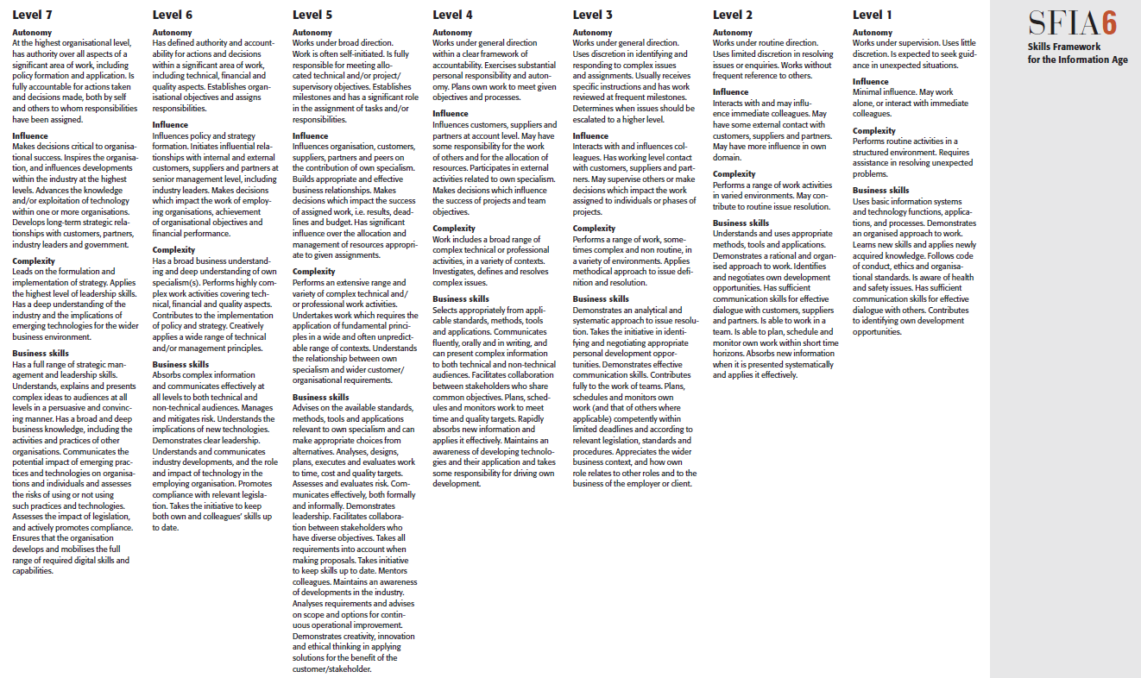

Figure 4-1 SFIA Levels of Responsibility

4.1.2 iCD Task Performance level
The iCD's Task Performance level (Table 4-2) evaluates the task performance of each employee from Level 0 to Level 4, (as shown in Table 3); this assigned task performance level is evaluated quarterly, half yearly, or at the end of a fiscal year. Organization members evaluate their task performance typically at the third level (Minor Task Category) of an assigned task. This evaluation directly impacts an individual's evaluation of the current fiscal year; salaries and promotions may also be linked to the evaluation result.
The task evaluation typically occurs on a fiscal year basis. This means for a specific task, even though the performance evaluation is very high in some year, it might be very low in the next year. This is possible, for example, due to a project member change, or some serious communication problem occurring in the next year, or an unexpected system problem causing a lack of project members. Similarly, the same task performance of the same organization member might fluctuate over years.
The SFIA Levels of Responsibility address all 7 levels; the SFIA Skill levels only address those at which the skill can be practiced. iCD has no prerequisite task level and anyone can conduct any task. However, some tasks are more difficult to conduct than others, for example, 'Business operations strategy formulation' is apparently difficult for a freshman to conduct, but the iCD assumes this task might be assigned to this freshman whatever the performance level might be.
Table 4-2. Task Evaluation Level

Level | Evaluation Criteria
Level 0 | No knowledge or experience
Level 1 | Has knowledge based on training
Level 2 | Can carry out with support or has such experience
Level 3 | Can carry out independently or has such experience
Level 4 | Can instruct others or has such experience

4.2 iCD Criteria for levels of Skill Mastery
Skill Mastery consists of seven levels from 1 to 7 (Table 4-3). Definitions for levels 1 to 4 differs for Technology, Methodology, and Related Knowledge in the skill category in order to clarify the differences in skill characteristics.
The definition for levels 5 to 7 is identical across the skills categories because the skill maturity level above level 5 represents a high-level contribution to society as a professional within any skill category. This means the skill maturity level goes up over level 5 to level 7 for an individual's career by continuous skill development. As a practical skill level in order to perform corresponding tasks, maturity level 4 is sufficient. However, the skill maturity level evaluates an individual’s professional commitment and contribution. The skill maturity level does not cover IT soft skills. An IT human skill is enough to judge if a member has a skill or not rather than leveling.
SFIA has no corresponding level to the iCD Criteria for levels of Skill Mastery.
Table 4-3 Criteria for Levels of Skill Mastery
Level 7 | Skills at the level of an industry leader who has influence on the market
Level 6 | Skills at the level of a recognized contributor to the industry
Level 5 | Skills at the level of a recognized contributor within affiliated associations and organizations
Level 4 | Level at which one is able to produce optimal solutions that take into account non-functional requirements, step outside of established tactics, and pass the advanced information technology examinations | Has mastered and can select the most suitable methods, and can freely apply the methods according to the situation | Is able to discuss what needs to be done with senior management within the industry or business they are involved in
Level 3 | Is able to create functional requirements and to work independently under limited circumstances | Is able to apply the proper method according to the problem, and has utilized the methods on-site and drawn conclusions | Has proposed solutions to the IT-related problem points in the industry and businesses they are involved in
Level 2 | Has implementation experience, and is able to use and apply the technology if instructions are available | Is able to perform analysis using the method, or is able to use the methodology under guidance | Understands the IT-related problem points in the industry and businesses they are involved in
Level 1 | Has knowledge, and understands lectures and presentations about technical content | Understands lectures and presentations about the method, understands and can explain what it is, and understands textbooks about it | Understands and can explain what kind of industry and business they are involved in, and understands public information such as securities reports
Skill Category | Technology | Methodology | Related Knowledge

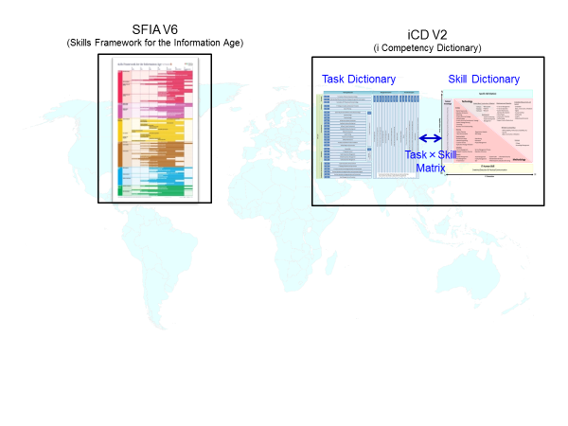

5 Summary of SFIA & iCD Comparison
- The i-CD is the property of the IPA (Information-technology Promotion Agency, Japan)
- In Japan, the IPA announced iCD trial version in Jul/2014; iCD2015 in Jul/2015. English version iCD available one year after.
- Used by 1000 companies in Japan, 27 countries globally
- Translated into English
- Updated annually
- The iCD consists of Task Dictionary and Skill Dictionary
- Task Dictionary corresponds to SFIA V2
- Task Dictionary is a four-layer structure (48, 200, 570, 2200)
- Skill Dictionary is a four-layer structure (5, 84, 460,10000)
- A Task × Skill matrix links the two dictionaries
- Both dictionaries have additional supporting tables.

- SFIA Foundation develops, maintains and makes available SFIA.
- The collaboration within UK companies in the 1980s and 90s resulted in SFIA Framework being published/adopted from the year 2000.
- SFIA has 20000 users worldwide in around 180 countries.
- Available in 6 languages (English, Spanish, Japanese, etc.)
- Updated every 2-3 years
- SFIA Framework consists from Skills/Levels Description/Levels of Responsibility/Levels Guiding Word entities.
- SFIA Framework is a 7 level framework with 4 generic responsibilities and 97 professional skills aligned to the 7 levels.
- The generic responsibilities and professional skills are used together.
- A reference guide provides the detailed description of Skills and Responsibilities

